**\*Pyramid**

**CODE:**

#include <iostream>

using namespace std;

int main()

{

int space, rows;

cout <<"Enter number of rows: ";

cin >> rows;

for(int i = 1, k = 0; i <= rows; ++i, k = 0)

{

for(space = 1; space <= rows-i; ++space)

{

cout <<" ";

}

while(k != 2*i-1)

{

cout << "* ";

++k;

}

cout << endl;

}

return 0;

}

**OUTPUT:**

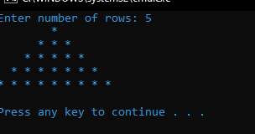

**Matrix**

**CODE:**

#include<iostream>

using namespace std;

int main() {

int product[10][10], r1=3, c1=3, r2=3, c2=3, i, j, k;

int a[3][3] = { {2, 4, 1} , {2, 3, 9} , {3, 1, 8} };

int b[3][3] = { {1, 2, 3} , {3, 6, 1} , {2, 4, 7} };

if (c1 != r2) {

cout<<"Column of first matrix should be equal to row of second matrix";

} else {

cout<<"The first matrix is:"<<endl;

for(i=0; i<r1; ++i) {

for(j=0; j<c1; ++j)

cout<<a[i][j]<<" ";

cout<<endl;

}

cout<<endl;

cout<<"The second matrix is:"<<endl;

for(i=0; i<r2; ++i) {

for(j=0; j<c2; ++j)

cout<<b[i][j]<<" ";

cout<<endl;

}

cout<<endl;

for(i=0; i<r1; ++i)

for(j=0; j<c2; ++j) {

product[i][j] = 0;

}

for(i=0; i<r1; ++i)

for(j=0; j<c2; ++j)

for(k=0; k<c1; ++k) {

product[i][j]+=a[i][k]*b[k][j];

}

cout<<"Product of the two matrices is:"<<endl;

for(i=0; i<r1; ++i) {

for(j=0; j<c2; ++j)

cout<<product[i][j]<<" ";

cout<<endl;

}

}

return 0;

}

**OUTPUT:**

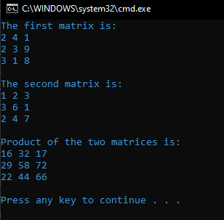

**Print 1 to 100**

**CODE:**

#include<iostream>

#include<conio.h>

using namespace std;

int main()

{

int i;

for(i=100;i>0;i--)

{

cout<<i<<"\t";

}

}

**OUTPUT:**

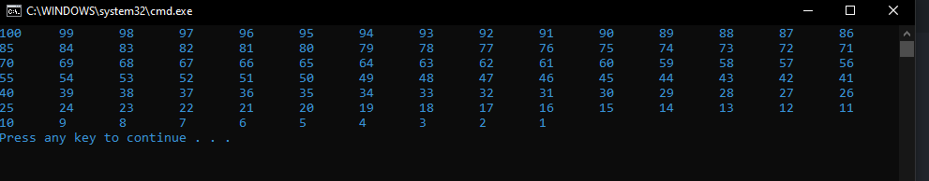

**Multiplication Table:**

**CODE:**

#include <iostream>

using namespace std;

int main()

{

int table = 9;

int length = 10;

int i = 1;

cout << "Multiplication table: " << table;

for(i=1; i<=length; i++)

cout << "\n" << i << " * " << table << " = " << i * table;

return 0;

}

**OUTPUT:**

